Angela Paolella

Grade: 96

Psychology 350

Major Project 2

01 NOV 2016

Analysis

For this project I chose to study my habits in relation to the number of hours I slept per night, the severity of my stress, and the number of minutes I spent engaged in physical activity. I chose to study such a particular set of data because I am preparing myself for the rigors of medical school and I thought that it would be useful to learn how I could best manage stress in a learning environment. Health in both body and mind are essential to, not only surviving medical school but, doing well enough to get into a decent residency. I narrowed my study down to these three variables because I feel as if they might have the some of the largest impacts on my performance in an academic setting and in my personal life.

My level of stress was the one of the most important variables I needed to track, as I hypothesised that it would depend on various factors which, for the purposes of this project, I narrowed down to how many hours I had slept the previous night and the number of minutes I spent exercising. I predicted that moderate physical activity would provide a healthy outlet for the intense stress I experience on a daily basis and also contribute to the quality of my sleep. Before taking this class I usually found that my ability to fall asleep at a decent hour was heavily influenced by whether or not I had worked out that day. Without exercise I tend to have a very difficult time falling asleep therefore reducing the number of hours I average per night considering the fact that I have to get up at a certain time everyday. Further I believed that the number of hours I slept would also help reduce the amount of stress I experienced because I am one of the unfortunate few that requires much more sleep than the average person of my age. To summarize I predicted that the correlations between variables would be of medium size and of negative quantity (for instance more physical activity would correlate with less severe stress) with relatively small standard deviations for each. The exception however would be the correlation between physical activity and sleep, which I hypothesised would be positive (more activity would leave me exhausted causing me to fall asleep earlier and therefore increase the number of hours slept).

The questions I used to track my three variables were quite simple as I previously alluded to and each variable was measured in a continuous way. For physical activity, I merely asked myself to note the number of minutes spent exercising, I was free to enter in whatever values I wanted so the variable was measured continuously. Now, as someone in decent shape I did not include light activities such as walking to school or cleaning the house, I only counted moderate to strenuous activity, but being a creature of habit I tend to only run and perform pushups and situps which I consider moderate. I believe that my habitual lifestyle is beneficial when it comes to recording data because it potentially lessens the chance my data will be largely skewed by confounding variables (for instance if I did light workouts one day and very strenuous ones on another, my level of stress might be due not simply to how long I exercised but also on the intensity). Moving forward, to record my level of stress I utilized a continuous, radio input with the four labels being, in order (1, 2, 3, 4): minor, moderate, intense, and severe. Finally, to record my sleep I merely entered in the number of hours I had gotten the previous night. Just like physical activity, this variable was continuous, I plugged in a number value, but for this variable in particular I used hours instead of minutes, as minutes would be a difficult number to both input and understand. In hindsight I think it would have been beneficial to also record the perceived quality of my sleep as better quality might explain why I slept less when I expected myself to require more rest.

I used the analyze tab on the website provided for us to find the average and standard deviation scores and also made my own graph for each. For physical activity, the average number of minutes I spent moderately exercising was 28.75 minutes per day and this average varied by approximately 5.99 minutes. It should be noted that I was quite bad and ended up skipping about half of daily workouts during the time that I conducted my research! I really overestimated how often I usually workout which came as a huge and worrisome surprise. I was quite stressed those few days and I hadn’t realized how little I had actually worked out, perhaps that is something to keep in mind if I decide to study this again on my own time. Next, my stress levels, which were only a bit more complicated to interpret had averaged to about 2.88 on a scale ranging from 1 (minor) to 4 (severe). The corresponding variance was 0.78 units, meaning that most of my responses fell between 2 (moderate) and approximately halfway between 3 (intense) and 4 (severe). I wasn’t really all that surprised to see that my stress levels were usually high, in fact I wasn’t at all surprised when I realized I had not even used the lowest rating (1, minor) in regards to recorded stress levels. Last but not least, my data for number of hours slept averaged to about 6.12 hours, varying 1.53 hours on average per night, meaning I usually slept between about 4.59 and 7.65 hours per night. I did end up sleeping more in this study than I normally do, but I did so purposely, I wanted to see how getting more (or less) sleep would influence my stress levels which would be hard to determine if I slept the same number of hours every single night so I wasn’t surprised to see that the standard deviation hovered around the level that it did which as I had mentioned was 1.53 hours.

The scores for each each variable remained relatively stable over time, obviously there was some day to day differences but nothing too large besides my data for physical activity. My exercise data varied quite a bit because on some days I would exercise between 20 and 40 minutes and on other days I would get no exercise at all so the comparison to 0 minutes is somewhat significant. It should be noted that I did make an additional exercise graph in which I changed the units from minutes to hours and I noticed that, much like the other graphs for stress and sleep, the new exercise graph was relatively stable. In addition to graphing each variable by itself, I also graphed all of the data on a single graph because it was easier to compare each variable and I noticed that sleep and stress tended to be positively related, meaning that when one increased the other did as well (this was a rough visualization, as I will discuss the correlation size later) but exercise again was a little harder to interpret.

When I calculated the correlation coefficients I realized that in order from largest to smallest absolute value using Cohen’s standards, the relationships were -0.3806 (physical activity and stress), 0.2777 (stress and sleep), and -0.2237 (physical activity and sleep). The size of the correlation between physical activity and stress was medium and expressed a negative relationship. I was correct about this correlation because I expected that when I exercised more I would experience less stress and vice versa, when I exercised less I would be more stressed. The size of the correlation between stress and sleep was almost medium but still between 0.1 and 0.3 so it was technically still classified as small and expressed a positive relationship. This result went against what I had expected because the data showed that when I was more stressed I also slept more and when I was less stressed I tended to sleep less. I suppose stress puts a significant strain on the body which in turn could make you require more sleep but I had originally expected the correlation to be negative. The size of the correlation between physical activity and sleep was small and expressed a negative relationship. This data also surprised me, when I was more active I slept less and vice versa, when I was less active I tended to sleep more. I speculate that this is because I sleep better when I exercise and therefore need fewer hours of sleep overall. This all being said, in lecture seven we stated that typical correlations in personality psychology were about 0.21 so all of my data is still pretty significant keeping that fact in mind.

I learned quite a bit about myself in this project, most importantly how to effectively study and analyze relevant data about myself to better strategize and manage stress at school, work, and in my personal life. I think that I will use this sort of experiment again on my own time because I feel as if fifteen distinct days did not yield enough information once I started analysing data (more data tends to paint a better picture than a very small amount). I had expected the variables to correlate more strongly than they did but I reminded myself that a correlation of 0.21 is very common in psychology. All in all, for the most part I was incorrect in my assumptions about the sign of the correlations (negative or positive) in addition to being incorrect how large or small the correlations would be when I made my prediction.

Condensed Excel Spreadsheet:

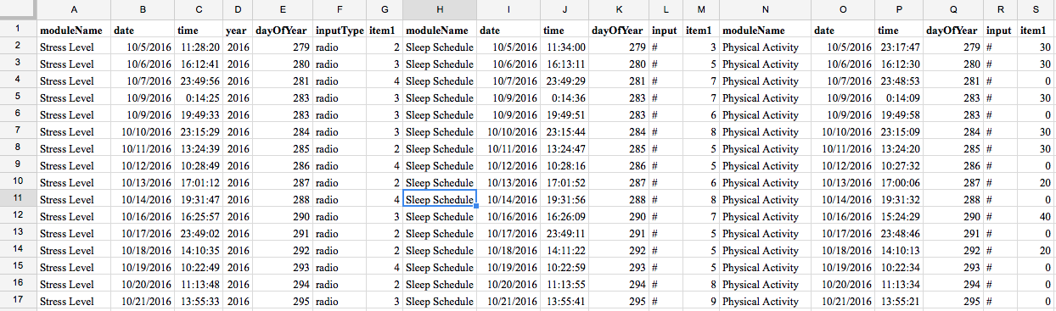

Graphs:

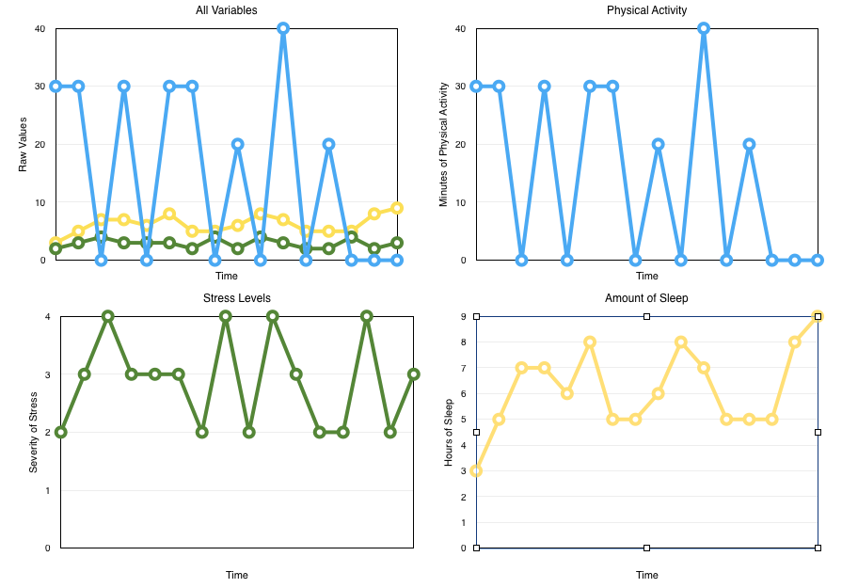

Raw Data:

paolell2,Physical Activity,paolell2,10/5/2016,23:17:47,2016,279,1740.96327314815,numbers,30,,,,,,,,,,endline

paolell2,Physical Activity,paolell2,10/6/2016,16:12:30,2016,280,1741.67013888889,numbers,30,,,,,,,,,,endline

paolell2,Physical Activity,paolell2,10/7/2016,23:48:53,2016,281,1742.97191203704,numbers,0,,,,,,,,,,endline

paolell2,Physical Activity,paolell2,10/9/2016,0:14:9,2016,283,1744.00393055556,numbers,30,,,,,,,,,,endline

paolell2,Physical Activity,paolell2,10/9/2016,19:49:58,2016,283,1744.8055462963,numbers,0,,,,,,,,,,endline

paolell2,Physical Activity,paolell2,10/10/2016,23:15:9,2016,284,1745.96254166667,numbers,30,,,,,,,,,,endline

paolell2,Physical Activity,paolell2,10/11/2016,13:24:20,2016,285,1746.54842592593,numbers,30,,,,,,,,,,endline

paolell2,Physical Activity,paolell2,10/12/2016,10:27:32,2016,286,1747.42431481481,numbers,0,,,,,,,,,,endline

paolell2,Physical Activity,paolell2,10/13/2016,17:0:6,2016,287,1748.70836111111,numbers,20,,,,,,,,,,endline

paolell2,Physical Activity,paolell2,10/14/2016,19:31:32,2016,288,1749.80042592593,numbers,0,,,,,,,,,,endline

paolell2,Physical Activity,paolell2,10/16/2016,15:24:29,2016,290,1751.63180092593,numbers,40,,,,,,,,,,endline

paolell2,Physical Activity,paolell2,10/17/2016,23:48:46,2016,291,1752.97187962963,numbers,0,,,,,,,,,,endline

paolell2,Physical Activity,paolell2,10/18/2016,14:10:13,2016,292,1753.5861712963,numbers,20,,,,,,,,,,endline

paolell2,Physical Activity,paolell2,10/19/2016,10:22:34,2016,293,1754.42293518519,numbers,0,,,,,,,,,,endline

paolell2,Physical Activity,paolell2,10/20/2016,11:13:34,2016,294,1755.46210185185,numbers,0,,,,,,,,,,endline

paolell2,Physical Activity,paolell2,10/21/2016,13:55:21,2016,295,1756.55704166667,numbers,0,,,,,,,,,,endline

paolell2,Stress Level,paolell2,10/5/2016,11:28:20,2016,279,1740.4662037037,radio,2,,,,,,,,,,endline

paolell2,Stress Level,paolell2,10/6/2016,16:12:41,2016,280,1741.67018981481,radio,3,,,,,,,,,,endline

paolell2,Stress Level,paolell2,10/7/2016,23:49:56,2016,281,1742.9722037037,radio,4,,,,,,,,,,endline

paolell2,Stress Level,paolell2,10/9/2016,0:14:25,2016,283,1744.00400462963,radio,3,,,,,,,,,,endline

paolell2,Stress Level,paolell2,10/9/2016,19:49:33,2016,283,1744.80543055556,radio,3,,,,,,,,,,endline

paolell2,Stress Level,paolell2,10/10/2016,23:15:29,2016,284,1745.96263425926,radio,3,,,,,,,,,,endline

paolell2,Stress Level,paolell2,10/11/2016,13:24:39,2016,285,1746.54851388889,radio,2,,,,,,,,,,endline

paolell2,Stress Level,paolell2,10/12/2016,10:28:49,2016,286,1747.4246712963,radio,4,,,,,,,,,,endline

paolell2,Stress Level,paolell2,10/13/2016,17:1:12,2016,287,1748.70866666667,radio,2,,,,,,,,,,endline

paolell2,Stress Level,paolell2,10/14/2016,19:31:47,2016,288,1749.80049537037,radio,4,,,,,,,,,,endline

paolell2,Stress Level,paolell2,10/16/2016,16:25:57,2016,290,1751.673875,radio,3,,,,,,,,,,endline

paolell2,Stress Level,paolell2,10/17/2016,23:49:2,2016,291,1752.9719537037,radio,2,,,,,,,,,,endline

paolell2,Stress Level,paolell2,10/18/2016,14:10:35,2016,292,1753.58627314815,radio,2,,,,,,,,,,endline

paolell2,Stress Level,paolell2,10/19/2016,10:22:49,2016,293,1754.42300462963,radio,4,,,,,,,,,,endline

paolell2,Stress Level,paolell2,10/20/2016,11:13:48,2016,294,1755.46216666667,radio,2,,,,,,,,,,endline

paolell2,Stress Level,paolell2,10/21/2016,13:55:33,2016,295,1756.55709722222,radio,3,,,,,,,,,,endline

paolell2,Sleep Schedule,paolell2,10/5/2016,11:34:0,2016,279,1740.46777777778,numbers,3,,,,,,,,,,endline

paolell2,Sleep Schedule,paolell2,10/6/2016,16:13:11,2016,280,1741.6703287037,numbers,5,,,,,,,,,,endline

paolell2,Sleep Schedule,paolell2,10/7/2016,23:49:29,2016,281,1742.9720787037,numbers,7,,,,,,,,,,endline

paolell2,Sleep Schedule,paolell2,10/9/2016,0:14:36,2016,283,1744.00405555556,numbers,7,,,,,,,,,,endline

paolell2,Sleep Schedule,paolell2,10/9/2016,19:49:51,2016,283,1744.80551388889,numbers,6,,,,,,,,,,endline

paolell2,Sleep Schedule,paolell2,10/10/2016,23:15:44,2016,284,1745.9627037037,numbers,8,,,,,,,,,,endline

paolell2,Sleep Schedule,paolell2,10/11/2016,13:24:47,2016,285,1746.54855092593,numbers,5,,,,,,,,,,endline

paolell2,Sleep Schedule,paolell2,10/11/2016,13:24:58,2016,285,1746.54860185185,numbers,5,,,,,,,,,,endline

paolell2,Sleep Schedule,paolell2,10/12/2016,10:28:16,2016,286,1747.42451851852,numbers,5,,,,,,,,,,endline

paolell2,Sleep Schedule,paolell2,10/13/2016,17:1:52,2016,287,1748.70885185185,numbers,6,,,,,,,,,,endline

paolell2,Sleep Schedule,paolell2,10/14/2016,19:31:56,2016,288,1749.80053703704,numbers,8,,,,,,,,,,endline

paolell2,Sleep Schedule,paolell2,10/16/2016,16:26:9,2016,290,1751.67393055556,numbers,7,,,,,,,,,,endline

paolell2,Sleep Schedule,paolell2,10/17/2016,23:49:11,2016,291,1752.97199537037,numbers,5,,,,,,,,,,endline

paolell2,Sleep Schedule,paolell2,10/18/2016,14:11:22,2016,292,1753.58649074074,numbers,5,,,,,,,,,,endline

paolell2,Sleep Schedule,paolell2,10/19/2016,10:22:59,2016,293,1754.42305092593,numbers,5,,,,,,,,,,endline

paolell2,Sleep Schedule,paolell2,10/20/2016,11:13:55,2016,294,1755.46219907407,numbers,8,,,,,,,,,,endline

paolell2,Sleep Schedule,paolell2,10/21/2016,13:55:41,2016,295,1756.55713425926,numbers,9,,,,,,,,,,endline